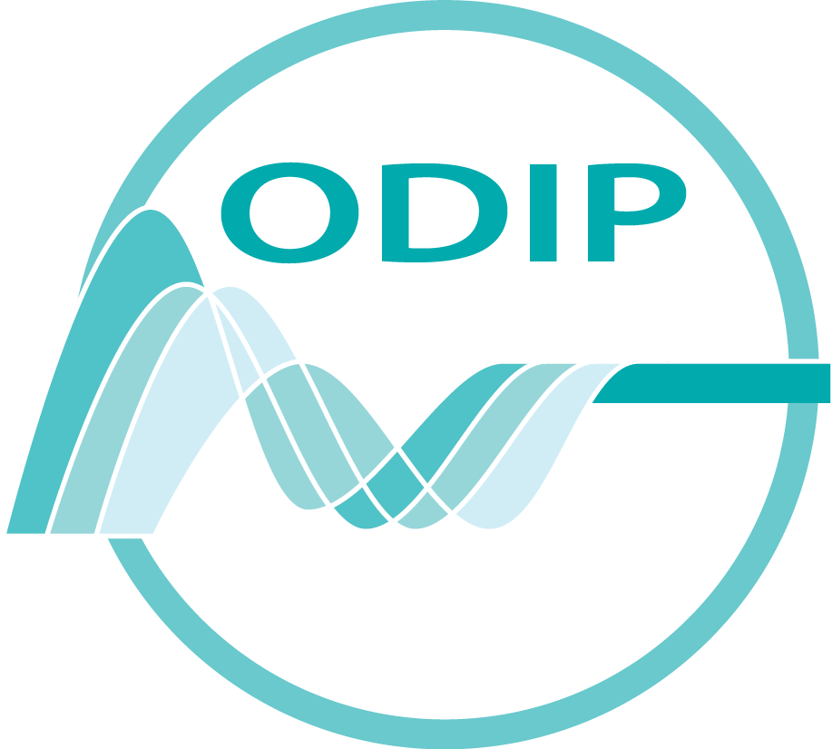

1st ODIP workshop

The first ODIP workshop will focus on the topics listed below. Each topic has been selected following the initial poll among all partners for a prioritized list of discussion topics. An expert for each topic from the three main geographic areas (Europe, USA and Australia) has been nominated and selected in consultation with the local representative for each of the regions.

Each topic has a nominated leader and a rapporteur will also be selected for each one on the first day of the workshop.

While every effort has been made to have a logical structure to the programme for the workshop it has been necessary to schedule some topics/discussions to accommodate those people who are participating in the workshop remotely from other time zones.

Workshop Topics

Topic | Title | Leader
Topic 1 | Common Vocabularies | Roy Lowry
Topic 2 | Metadata formats for discovery | Enrico Boldrini
Topic 3 | Metadata and data exchange mechanisms | Dick Schaap
Topic 4 | Data formats | Adam Leadbetter
Topic 5 | Observation and Measurements (O&M) metadata formats | Simon Cox
Topic 6 | Added value viewing services | Ben Domenico

Programme

Monday, 25 February 2013

9:30 – 10:00 Registration
10:00- 10:30 Welcome
Peter Pissierssens (IODE)
Workshop logistics
Introduction of attendees
(Name, Country, institution, main responsibility, expectations for this workshop: 30 seconds max.)

10:30 – 11:00 Overview of the ODIP project
Helen Glaves (ODIP project co-ordinator)

11:00 – 11:30 Break

Topic 1

11:30 – 12:00 Common Vocabularies
Roy Lowry (EU) & Kim Finney (AU)

12:00 – 13:00 Discussion
Lead by Roy Lowry with Adam Leadbetter (EU), Karen Stocks (USA), Kim Finney (AU), Simon Cox (AU)

13:00 – 14:00 Lunch

Topic 2

14:00 – 14:30 Metadata formats for discovery
Enrico Boldrini (EU), Irina Bastrakova (AU)
14:30 – 15:30 Discussion
Lead by Enrico Boldrini (EU) with Bob Arko (USA) and Irina Bastrakova (AU)

15: 30 -16:00 Break

Topic 3

16:00 – 16:30 Metadata and data exchange mechanisms
Dick Schaap (EU); Guillaume Galibert (AU)

16:30 – 17:30 Discussion
Lead by Dick Schaap (EU) with Bob Arko (USA) and Guillaume Galibert (AU)

Tuesday, 26 February

USA: Rolling Deck 2 Repository (R2R)
Update on R2R: Bob Arko and Karen Stocks

9:00 – 9:30 Overview of the R2R program: products, vocabularies, formats and metadata

9:30 – 10:00 R2R Interoperability and contributions to ODIP

10:00 – 11:00 Discussion: R2R-ODIP collaboration next steps

11:00 – 11:30 Break

Topic 4

11:30 – 12:00 Data formats
Adam Leadbetter(EU), Guillaume Galibert (AU)

12:00 – 13:00 Discussion
Lead by Adam Leadbetter (EU) with Guillaume Galibert (AU) and R2R team

13:00 – 14:00 Lunch

Topic 5

14:00 – 14:30 Observation and Measurements (O&M) metadata formats
Simon Cox(AU), Paolo Diviacco(EU), Janet Fredericks (USA)

14:30 – 15:30 Discussion
Lead by Simon Cox (AU) with Paolo Diviacco (EU) and
Janet Fredericks (USA)

15: 30 -16:00 Break

Topic 6

16:00 – 16:45 Added value viewing services
Ben Domenico (USA), Thomas Loubrieu (EU), Scott Bainbridge(AU)

16:45 – 17:15 Discussion
Lead by Ben Domenico (USA) with Thomas Loubrieu (EU) and
Scott Bainbridge (AU)

USA: NODC
Overview: Margarita Gregg, Ken Casey and Jacqueline Mise

17:15 – 17:35 Overview of NODC activities including potential contributions to ODIP

17:35 – 17:45 Discussion

Wednesday, 27 February

Australia: IMOS/AODN
Update on IMOS/AODN Scott Bainbridge, Guillaume Galibert and Irina Bastrakova

9:00 -9:30 Overview of the IMOS/AODN program

9:30 – 10:00 AODN Interoperability and contributions to ODIP

10:00 – 10:30 Group discussion of AODN-ODIP collaboration next steps

10:30- 11:00 Break

11:00 – 11:30 Overview of interoperability opportunities, low hanging fruit, based on previous sessions (tbd)

11:30 – 12:30 Discussion (tbd)

12:30 – 13:30 Lunch

Excursion to Bruges (sponsored by MARIS)
Bus departs at 13:30 and will return at 21:30 (departing Bruges 21:00)

Thursday, 28 February

9:00 – 9:30 Overview of ODIP prototype development

9:30 – 10:00 Potential prototype projects

10:00 – 11:00 Discussion

11:00 – 11:30 Break

11:30 – 13:00 Topic break-out sessions: an opportunity for informal topic lead discussions.
(A rapporteur will be nominated for each break-out group at the start of the session)

Steering Committee Meeting | Topic 1 | Topic 2 | Topic 3 | Topic 4 | Topic 5 | Topic 6
 | Chair: Roy Lowry | Chair: Enrico Boldrini | Chair: Guillaume Galibert | Chair: Adam Leadbetter | Chair: Simon Cox | Chair: Ben Domenico

13:00 – 14:00 Lunch

14:00 – 15:30 Topic break- out sessions (continued)

Steering Committee Meeting | Topic 1 | Topic 2 | Topic 3 | Topic 4 | Topic 5 | Topic 6
 | Chair: Roy Lowry | Chair: Enrico Boldrini | Chair: Guillaume Galibert | Chair: Adam Leadbetter | Chair: Simon Cox | Chair: Ben Domenico

15:30 – 16:30 Summary for each topic : 10 minutes for each

Topic | Title | Leader
Topic 1 | Common Vocabularies | TBC
Topic 2 | Metadata formats for discovery | Enrico Boldrini
Topic 3 | Metadata and data exchange mechanisms | Dick Schaap
Topic 4 | Data formats | TBC
Topic 5 | Observation and Measurements (O&M) metadata formats | Simon Cox
Topic 6 | Added value viewing services | Ben Domenico

16:30 – 17:00 Plans for next 9 months including 2nd ODIP workshop

17:00 Workshop close

